### 

### Semester One Examination, 2020

### Question/Answer booklet

# SPECIALIST MATHS

**UNIT 3**

## Section One:

## Calculator-free

Your Name

Your Teacher’s Name

## Time allowed for this section

Reading time before commencing work: five minutes

Working time: fifty minutes

## Materials required/recommended for this section

***To be provided by the supervisor***

This Question/Answer booklet

Formula sheet

***To be provided by the candidate***

Standard items: pens (blue/black preferred), pencils (including coloured), sharpener, correction fluid/tape, eraser, ruler, highlighters

Special items: nil

## Important note to candidates

No other items may be taken into the examination room. It is **your** responsibility to ensure that you do not have any unauthorised material. If you have any unauthorised material with you, hand it to the supervisor **before** reading any further.

|  |  |  |  |  |  |
| --- | --- | --- | --- | --- | --- |
| Question | Mark | Max | Question | Mark | Max |
| 1 | 6 |  | 5 | 5 |  |
| 2 | 10 |  | 6 | 8 |  |
| 3 | 9 |  | 7 | 9 |  |
| 4 | 3 |  |

**Structure of this paper**

|  |  |  |  |  |  |
| --- | --- | --- | --- | --- | --- |
| Section | Number of questions available | Number of questions to be answered | Working time (minutes) | Marks available | Percentage of examination |
| Section One:  Calculator-free | 7 | 7 | 50 | 50 | 33 |
| Section Two:  Calculator-assumed | 10 | 10 | 100 | 100 | 67 |
|  |  |  |  | **Total** | 100 |

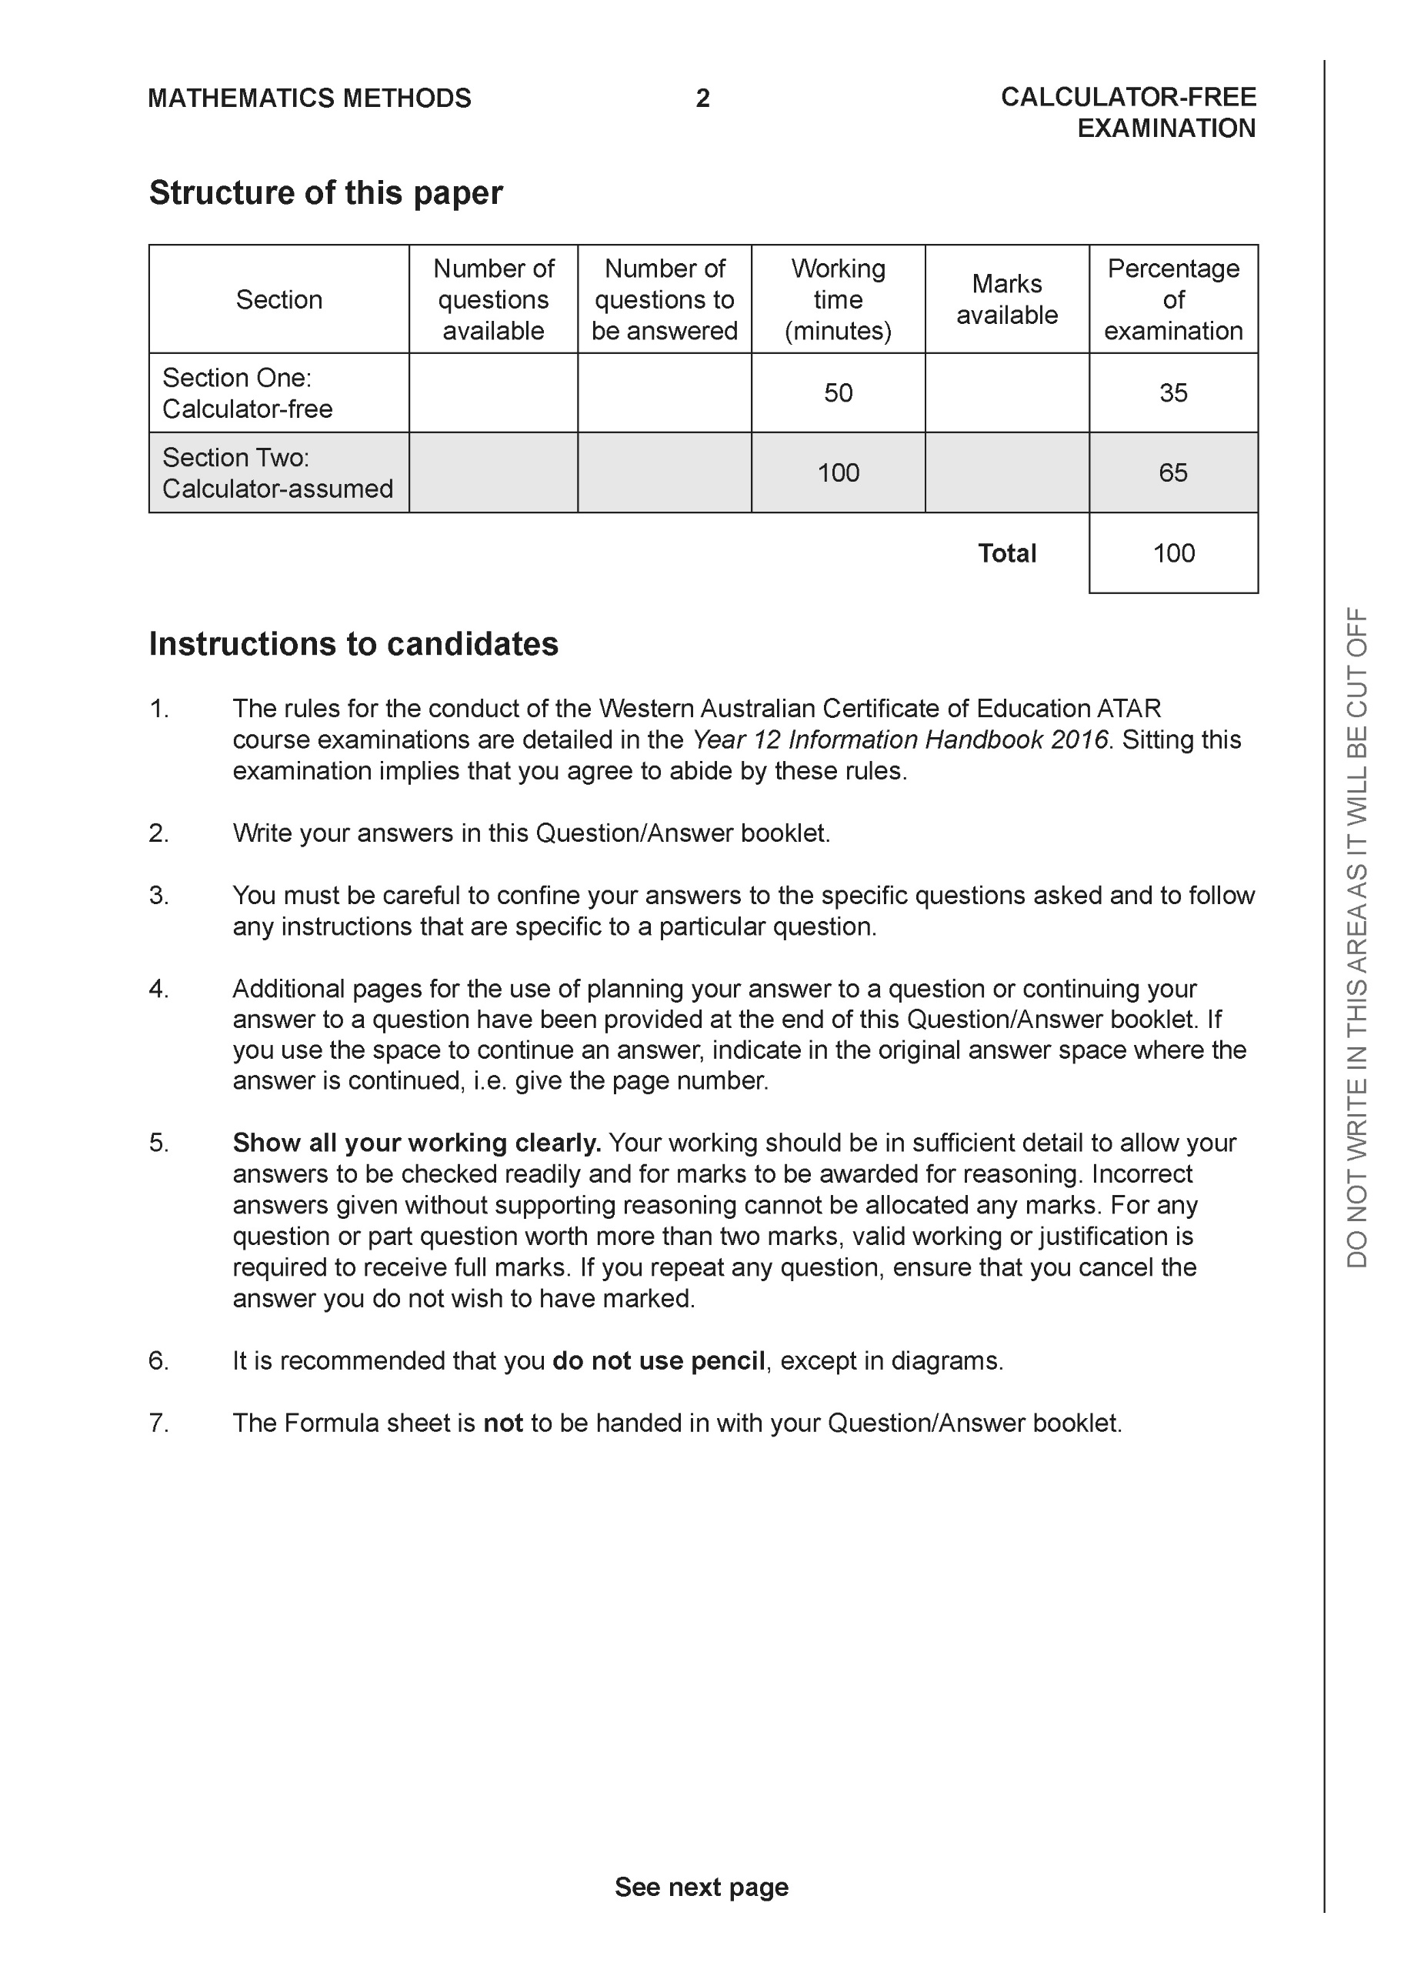

**Section One: Calculator-free (50 Marks)**

This section has **seven (7)** questions. Answer **all** questions. Write your answers in the spaces provided.

Spare pages are included at the end of this booklet. They can be used for planning your responses and/or as additional space if required to continue an answer.

● Planning: If you use the spare pages for planning, indicate this clearly at the top of the page.

● Continuing an answer: If you need to use the space to continue an answer, indicate in the original answer space where the answer is continued, i.e. give the page number. Fill in the number of the question that you are continuing to answer at the top of the page.

Working time: 50 minutes.

**Question 1 (6 marks)**

Consider the polynomial .

(a) Determine  (1 mark)

(b) Show that  is a factor of . (2 marks)

(c) Determine all the roots to  (3 marks)

**Question 2 (10 marks)**

Consider the functions  & .

1. Determine the natural domain and range of . (2 marks)
2. Determine the rule for  and state its natural domain and range. (3 marks)
3. Determine the rule and natural domain for . Explain why the composite exists.

(3 marks)

1. Does ? Justify. (2 marks)

**Question 3 (9 marks)**

Consider the function  which is drawn below and defined only for .

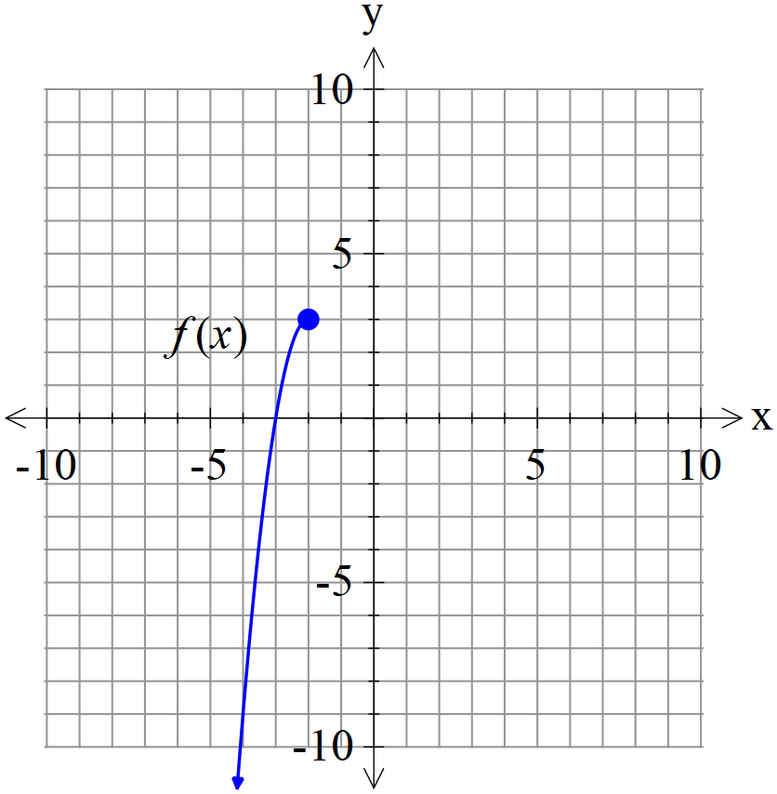

1. Sketch  on the axes above. (2 marks)
2. Given that , determine the rule for  and state the domain and range. (4 marks)
3. Determine the exact solution(s) to if any. (3 marks)

**Question 4 (3 marks)**

Consider the complex equation  for any positive integer . The  roots are designated .

Let , determine  for any positive integer .Explain.

**Question 5 (5 marks)**

|  |  |
| --- | --- |
|  | The function  is drawn to the left where  are all integers. |

Complete the following table.

|  |  |  |  |  |
| --- | --- | --- | --- | --- |
| a | b | c | p | q |
|  |  |  |  |  |

**Question 6 (8 marks)**

Consider the function  which is drawn below and is defined for .

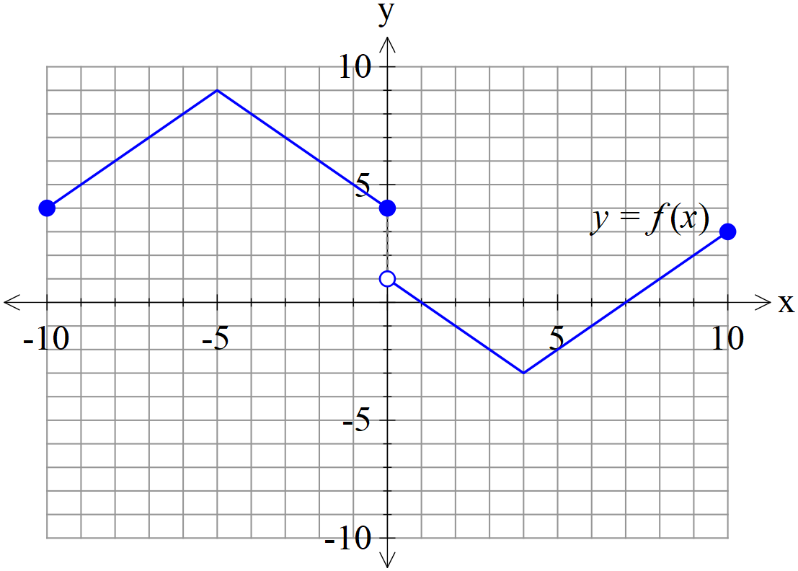

(a) Sketch  on the axes below. (2 marks)

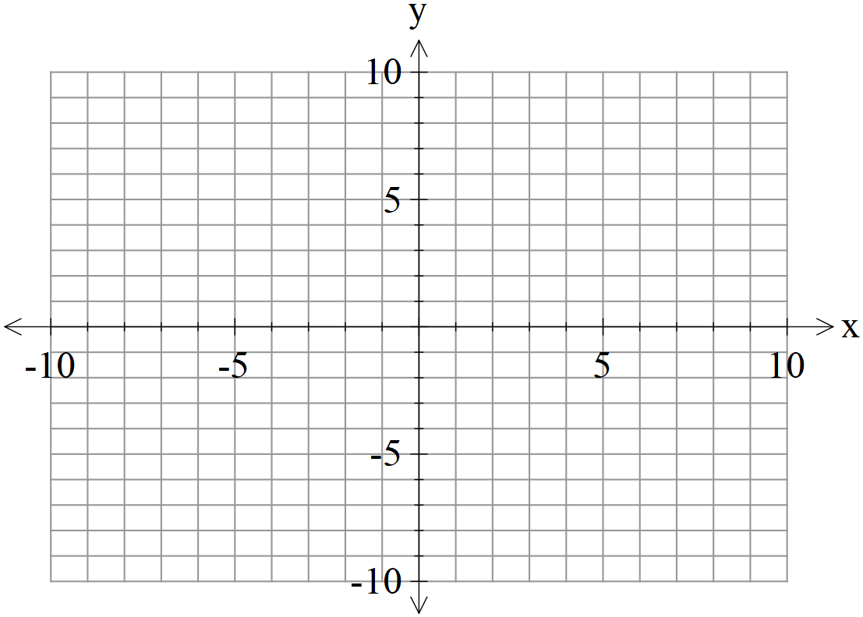

(b) Sketch  on the axes below. (3 marks)



(c) Sketch  on the axes below. (3 marks)



**Question 7 (9 marks)**

Consider a projectile that has an initial speed, , at an angle of  with the horizontal

that moves with an acceleration of  where  is a constant.

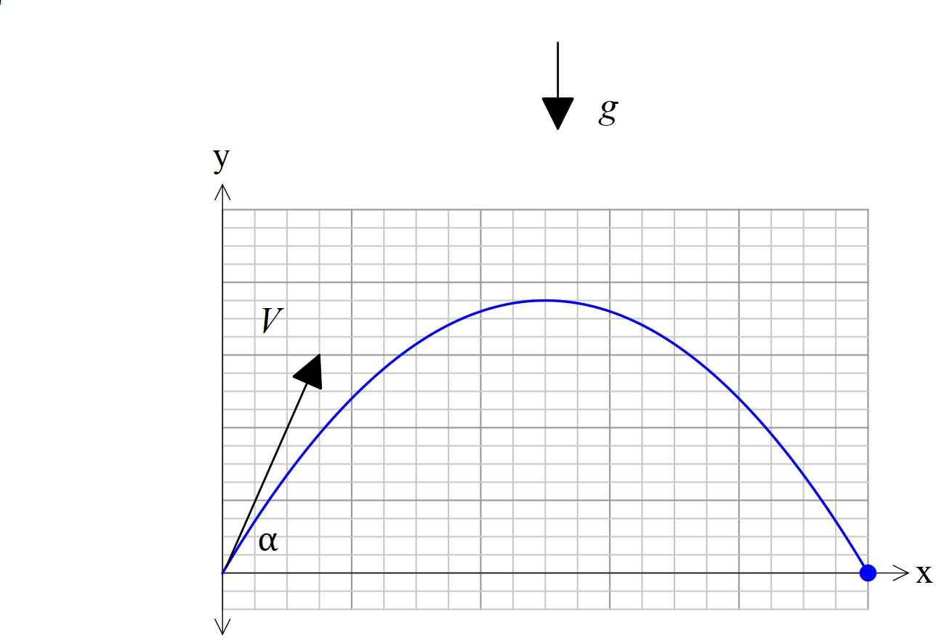

1. If the projectile begins at the origin, show that a time, , and using vector calculus that the velocity vector is given by: (2 marks)



1. In terms of  derive the cartesian equation of the projectile. (4 marks)

Q7 cont

1. Given that  derive the following equation.

. (3 marks)